Mr. Sheldon Jones Rebecca Freeland
Superintendent of Schools Talent Pipeline Lead

Richland Parish School System

GOOD TO GREAT APPLICATION

P.O. Box 599 Telephone (318) 728-5964
Rayville, Louisiana 71269 Fax (318) 728-6481

Date__________________________ Social Security No.___________________________

Name: _______________________________________________________________________________
Last First Middle Maiden

Address: _____________________________________________________________________________
Street

______________________________________________________________________________
City State Zip

Telephone: ____________________ Other Telephone: _________________ Cell Phone:______________

Certification: State_____________________ Class (or Type)_______________ Number______________

Areas of Certification: ____________________________________________________________________

Applying to attend as: Circle one Teacher Participant Leader Participant

**Please note leader participants are only selected if they have staff who are attending institute.

General Information
- After filing an application, all applicants for this leadership positon will then go through a vetting process; all qualifying applicants will be presented to the school system’s principal for final recommendation for leadership.
- Remember to submit a copy of your current teaching certificate and the completed screening activity at the end of this application.
- Principals, supervisors and others listed in this application may be contacted for references.
- Agreement to release of all personnel evaluation results is required to be considered for this professional development opportunity.
- The Richland Parish School System does not discriminate on the basis of race, color, national origin, sex, religion, age or disability in employment or the provision of services. Richland Parish School Board is an equal opportunity employer.
- If chosen as a participant I will be available to meet all expectations outlined in the Good to Great Flyer. Please note that all training dates are located in New Orleans, LA.

If you agree to the terms outlined above sign here:___________________________________________________

Teaching Experience
School  Parish/District | Address  (Please Provide  Complete Address) | Telephone | Principal | Grade or Subject | # of Years | Dates

Are you currently under contract? Yes _______ No _______ If yes, expiration date _____________________
Have you ever been discharged, requested to resign, or refused tenure? Yes ____________ No ______________
If yes, please explain on separate page.
Are you a retiree with the state of Louisiana? Yes_____ No______ If yes, what type of retiree? (Circle One)

Professional/Leadership Activities
Professional Organizations, Committees, Presentations, Publications:
__________________________________________________________________________________________
__________________________________________________________________________________________
__________________________________________________________________________________________
__________________________________________________________________________________________

Certification of Payee

I certify that any stipend and travel request is just and true in all respects. I will repay the district 100 percent of all stipends and travel disbursed if I voluntarily resign prior to the start or during the 2020-2021 school year. I hereby agree to pay any and all balances due at that time to District in full upon demand. In the event I do not make such payment in full upon demand, I knowingly and voluntarily authorize District to deduct from my wages any amount owed by me to District under this agreement. Upon referral of this debt by District to an attorney, I further agree to pay attorney’s fees in addition to the balance I owe.

For office use only:
Date:____________
Amt. _____________
Code:_________________

_____________________________ ______________________________
Payee Signature LEA Authority
Screening Activity

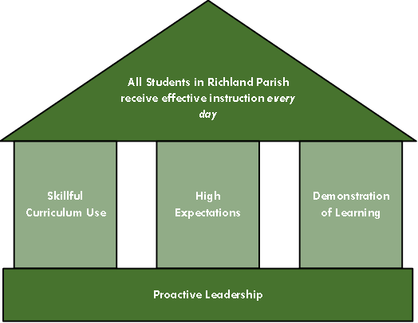

Directions: Please reflect and respond to the following in no more than 300 words. Review Richland Parish’s Instructional Framework (above) and the Good to Great 2020 flyer (i.e., teacher or leader). Describe why you believe Richland Parish should invest in you for this unique professional development opportunity.

